Software Requirements Specification
for
eGuideDog
Echo TTS



Version 1.0
Prepared by Theodoros Malachias
10/1/2019

Table of Contents
Table of Contents 2
Revision History 2
1. Introduction 3
1.1 Purpose
1.2 Document Conventions 3
1.3 Intended Audience and Reading Suggestions 3
1.4 Product Scope 3
1.5 References 3
2. Overall Description 4
2.1 Product Perspective 4
2.2 Product Functions 4
2.3 User Classes and Characteristics 4
2.4 Operating Environment 5
2.5 Design and Implementation Constraints 5
2.6 User Documentation 5
3. External Interface Requirements 6
3.1 User Interfaces 6
3.2 Hardware Interfaces 7
3.3 Software Interfaces 7
3.4 Communications Interfaces 7
4. System Features 8
4.1 Hear Everything you write 8
4.2 Save a the sound of the written text into .wav file and Play it 8

Revision History
Name | Date | Reason For Changes | Version
Theodoros Malachias | 10/01/19 | Initial Software Requirements Specification draft | 1.0

Introduction

Purpose
This Document intends to describe and analyze, the potential and the requirements of the eGuideDog Ekho TTS(text-to-speech) open source software.

Document Conventions
Everything underlined is a website. Use control + click to move to the website.

Intended Audience and Reading Suggestions

The Document is intended for the project manager Cameron Wong, every other programmer/developer that wants to learn more about the open source project and the client/user that needs more information about the project.

Project Scope
Ekho (余音) is a free, open source and multilingual text-to-speech (TTS) software. It supports Cantonese (Chinese dialect spoken in Hong Kong and part of Guangdong province), Mandarin (standard Chinese), Toisanese, Zhaoan Hakka (a dialect in Taiwan), Tibetan, Ngangien (an ancient Chinese before Yuan Dynasty) and Korean (in trial). It can also speak English through eSpeak or Festival. Ekho supports Linux, Windows and Android platforms.

References
eGuideDog Site (Ekho TTS)
Sourceforge

Overall Description

Product Perspective
Project Ekho TTS is a member of the project eGuideDog (free software for the Blind.
There are two more members, WebSpeech and WebAnywhere which focus mostly on Web facilities for the blind people.

There is another member called eGuideDog Linux (http://www.eguidedog.net/linux.php). It’s a Linux distribution for Chinese blind. But there is no English document for it.
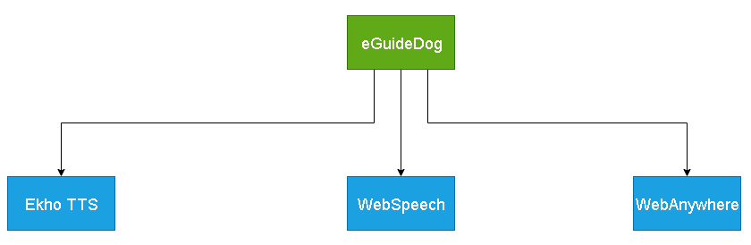

Product Functions
Write some text and let the Ekho Speak it for you. You can choose the voice you like, the rate and the volume of the voice, as well as the format of it.
Also, user can load a .wav file and let Ekho speak it out.

User Classes and Characteristics
Many people can use this project in different ways. Some may need to implement the project to another project for the help of blind people. Also if someone wants to help a blind person he could install the program to the blind person's computer, to give him/her the opportunity to hear everything is written.

Operating Environment
The program is available in Linux, Windows, Android platforms
Here are some recommended versions:
- Linux: ekho-7.6.tar.xz (53M)
- Linux (with pinyin-huang voice): ekho-7.7.1.tar.xz (88M)
- Windows (32bit, SAPI5): ekho-6.5.exe (37M)
- Windows (32bit, SAPI5, for Chinese-Spanish bilingual users): ekho- spanish-4.9.3.exe (21M)
- Android 4.0+: ekho-5.8.apk (12M) with Cantonese and English
- Android 2.x: ekho-5.6.apk (5.8M)

More at: Website

Design and Implementation Constraints
Ekho TTS consumes about 256MB memory for each voice. It’s written in C++ language. It requires following library to build (see file INSTALL in its source code):
* libespeak-dev
* libsndfile1-dev (http://www.mega-nerd.com/libsndfile/)
* libpulse-dev
* libncurses5-dev (required by --enable-festival)
* libestools-dev (optionally required by --enable-festival)
* festival-dev (optionally required by --enable-festival)
* libvorbis-dev (optional)
* libmp3lame-dev (optional)
* libdotconf-dev (required by --enable-speechd)
* texinfo

User Documentation
Here is some help for the installation in Linux/Raspberry Pi Users.

How to Install Ekho (for Linux and Raspberry Pi)

External Interface Requirements

User Interfaces
Windows GUI:

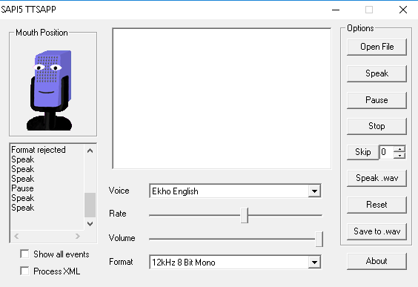
Windows GUI gives the user many options that we list below:
- Open A file to be spoken
- Speak written text from the text-box in the middle
- Pause the speaking
- Skip words
- Listen to a .wav file
- Reset the program
- Save TTS to .wav
- Set the voice as you like

Hardware Interfaces
Ekho TTS does not communicate directly to hardware. It generates speech output through PulseAudio on Linux and SAPI5 on Windows.

Software Interfaces
On Linux platform, Ekho TTS uses PulseAudio to generate speech output. Hardware supported by PulseAudio should supports Ekho TTS. Ekho TTS also implements an API for speech-dispatcher which is used by Orca screen reader.

On Windows platform, Ekho TTS impliments SAPI5. This is a standard Speech API on Windows platform.

Communications Interfaces
On Linux platform, Ekho TTS can be used in three ways:
- Standalone command line tools to generate speech output to speaker or file.
- Server-client mode. Ekho TTS can be run as server or client. When we build a speech server (for WebSpeech), we can run one Ekho TTS process as a server. And run another Ekho TTS process as client. The difference between the mode and standalone mode is that server mode doesn’t need to do the initialization process again and again which can be more responsively.
- Run as a worker of speech-dispatcher. Speech-dispatcher is a standard speech API for TTS which can be easily communicate with screen readers like Orca.

On Windows platform, all communication is made through SAPI5.

System Features

Hear everything you write
Echo TTS gives you the potential to hear everything you write or you copied to a textbox provided. This means that you can hear a long message/story or even a whole book just by copying its context into the textbox.

Save a the sound of the written text into .wav file and Play it
Program gives you the utility to save the sound of the written text to a .wav file. Also, it gives you the ability to play that .wav file or any other .wav file you like.

